**EXPERIMENT#4**

**Aim: Design of combinational logic circuits using MUX, Encoder and seven segment displays.**

**Exercise#1:** Design full adder using in-built block of (i) 4:1 multiplexer with initial carry as input line and, (ii) 8:1 multiplexer

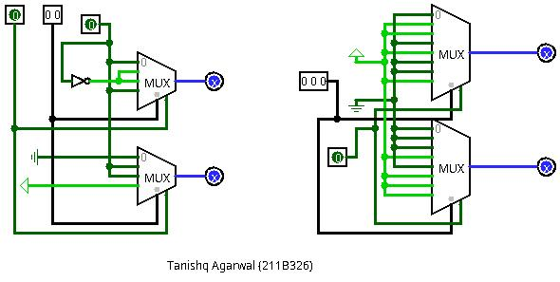**Logic Diagram:**

**Exercise#2:** Design a logic circuit (using in-built block of priority encoder, hex display and seven segment display) which display ‘E’, ‘O’ and ‘P’ if input octal number is even, odd and prime respectively.

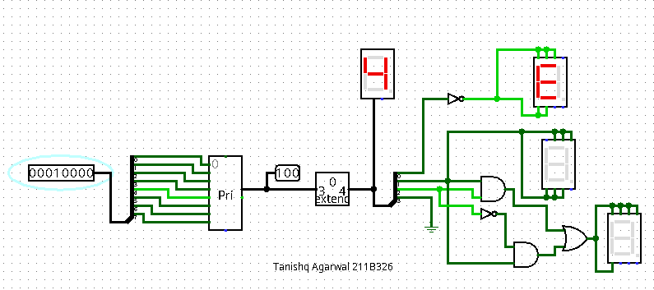**Logic Diagram:**

**Exercise#3:** Design calendar logic circuit to show the number of days in a given month. Display input month and leap year using two hex displays and number of days in outputs using eight seven segment displays.

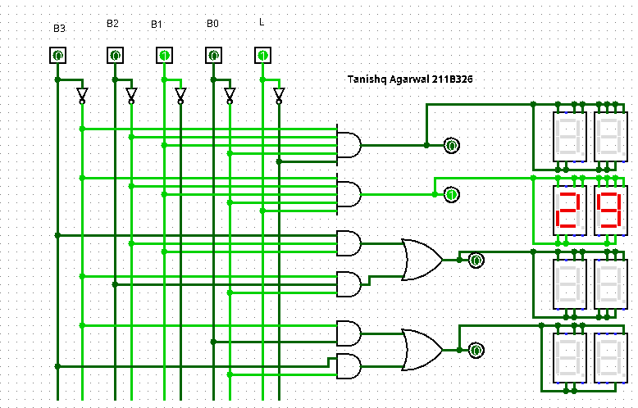**Logic Diagram:**

**Exercise#4:** Design logic circuit to determine whether the input year is leap year or not. Use four hex displays to show four decimal digits of input year and one hex display to show output.

**Logic Diagram:**

